# Technical Infrastructure

# Development Environment:

## Dreamweaver:

Dreamweaver is a web designing software developed by adobe, suitable for both beginners and professionals. It allows its user to write the code and test it in the split screen during the design process. It is easy, efficient and reliable. One can choose between the code view, the split view and the design view and see the live preview once the changes to the code is saved.

Apart from the website coding feature, the software also has an in-built FTP feature, which allows one to upload the website files.

## Xampp:

Xampp is a free software developed and distributed by Apache friends, which makes your system the local server for the website. It consists of Apache HTTP server, Maria DB, Perl and php language interpreters.

It is easy to install and lets you start or stop a service Like Apache, MySQL etc. with the click of a button.

One can easily change the default setting and also, set the ports it uses to run the services.

# Development Tools:

## Sublime Text:

Sublime Text is a text editor which comes handy while coding. It is a simplified alternative to dreamweaver. Some features that sublime text users enjoy that dreamweaver users can’t are:

1. One can do multiple edits at a time using its multiple cursor feature, which is absent in dreamweaver.
2. Previewing lengthy code/ code that runs in multiple pages, using the code preview feature.
3. Many handy shortcuts for quick code editing.
4. Bookmarking specific points/ areas of the code allows for easy and quick access to the code.
5. It has a huge repository of plugins that can be used to add extra features that are missing, like the FTP feature offered by dreamweaver can be added to sublime text using the sublime SFTP plugin.

## Winscp:

Winscp is a free software that allows you to transfer files to the database using a secure shell encrypted protocol. Its security is something that keep it ahead of its competitors like filezilla.

Some other benefits of using Winscp are as follows:

1. Automatic file synchronization:

Winscp can automatically synchronize the changes made to files and update them on the server. It allows you to select the files that should be monitored for changes, set the frequency to check the file etc. All one needs to do is turn this feature on and then the software takes care of the synchronization as long as it is on.

1. Synchronized browsing:

This feature is absent in filezilla but can be found in cuteFTP. This feature, allows you to navigate through the folders on the server, while you are navigating through the same folder on your local device.

## Photoshop:

Photoshop is a widely used photo editing software. It allows you to do minute changes to the images as per the requirements. Photo restoration, masking, designing, resizing and photo retouching are some of the features of Photoshop used in everyday life.

## phpMyAdmin:

phpmyadmin is an open source tool to handle MySQL ad Maria databases. It has an easy to manage user interface that allows you to quickly run SQL queries right from its SQL section. You can create tables, delete them and alter them as required. Apart from this it allows you to see the structure of the table created and the data stored in them. One can run queries ranging from simple “SELECT * FROM table_name” to more complex relational database queries.

# Programming Languages Used:

## MySQL:

MySQL is a freely available relational database management system that uses SQL language. It is used to manage the data in the database using tables. It is simple and easy to understand and use. Creating, deleting, altering and updating tables can be done in MySQL with simple “Insert”, “Delete”, “Alter” and “Update” commands.

Apart from these, it is highly secure, reliable, scalable and fast. Support for MySQL is available 24x7 as it has a huge developer community that contributes to solving MySQL issues. Query optimization, security audits and performance tuning are a few ways to improve the performance of MySQL.

## PHP:

PHP is a server side scripting language that can help developers make dynamic web pages. Unlike html, PHP does the execution of the code on the server side, while html does it in the client’s browser. This feature makes it a good option for web development. Some of the famous sites like Facebook, Yahoo, Wikipedia, Tumbler and Flicker use PHP to quickly load pages on the client’s side.

PHP can be easily integrated in html using the <?php?> tag. The PHP code is written after the “<?php” sign and a PHP script in html ends with the “?>” sign.

PHP is much similar to C and C++ languages and is easy to learn. It can also be applied for automating some processes like processing a form’s data, building new pages in a site using recently entered data, etc.

## HTML:

HTML is one of the most popular coding language on the web. It allows one to create web pages to display its contents. It is easy to learn and use and is supported by almost all the browsers.

Apart from these benefits, it also integrates with other programming languages like CSS, Javascript, PHP etc.

With many tools around, creating HTML pages have become more simpler, easy and less time consuming. However, security is a major concern when building html sites. Also, when coding multi page sites, one might face difficulties in finding a particular code as it gets complex and difficult to manage.

## CSS:

CSS is a styling language that add beauty to html pages. It consists of a set of rules that define the way elements of html should look like. It is easy to integrate it with html and can be done using the link tag in html’s header. It is easy to understand and implement and search engine friendly.

It has a number of tags that allow one to precisely modify the looks of a web page and is supported by almost all the browsers and devices.

## Javascript:

Javascript is another web development language used to load data on the fly to websites. It is very fast, simple and easy to implement. Its ability to dynamically load data is one of its many features that makes it a good choice for big sites.

It can be integrated to html pages using a simple <script> tag and is recommended for sites that have huge code on one page.

# Project Collaboration Tools:

## Github:

Github is an online service that lets developers collaborate on a project and track changes made to the code. It first started as a tool to track changes to linux and also track the software that big companies were coding and was initially called Git.

Github allows you to showcase your work to other developers. It supports a wide variety of programming languages and integrates with some big platforms like Amazon and Google cloud.

# Source Code Repositories:

https://github.com/suhasjoshua/ict_project07

About us page:

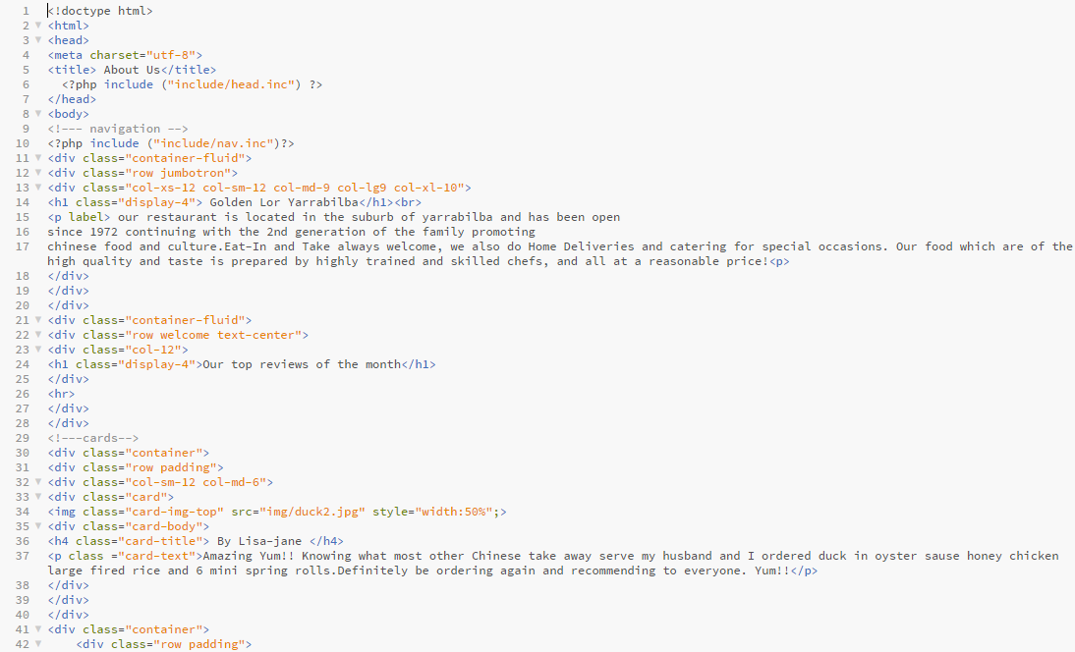

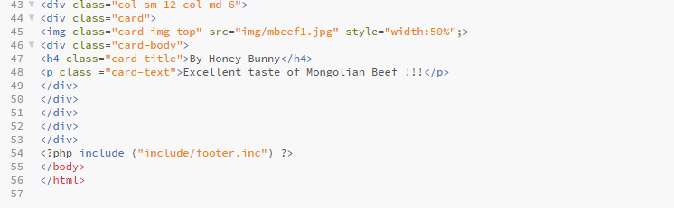

Admin login process

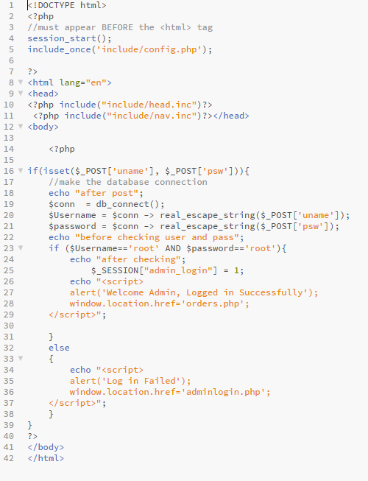

Admin login

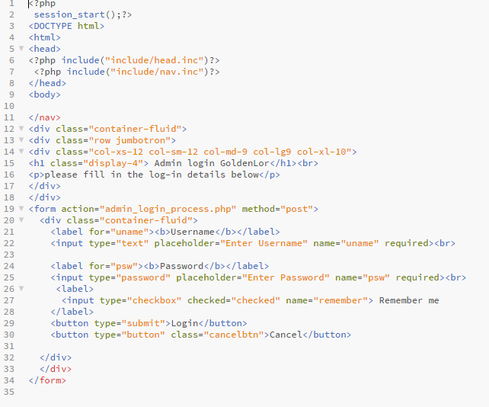

Adminlogout

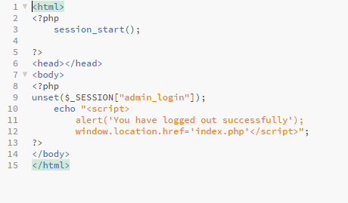

Cart

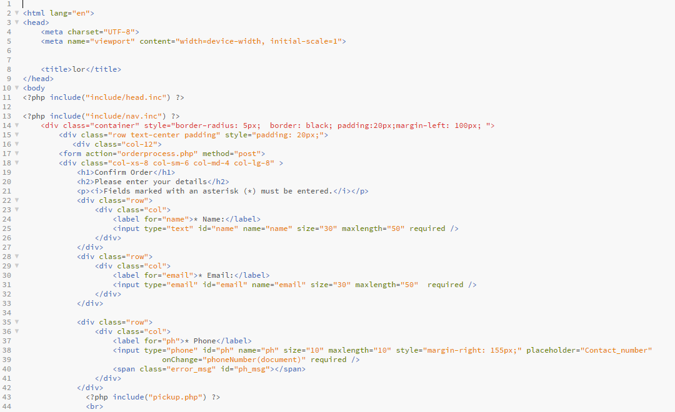

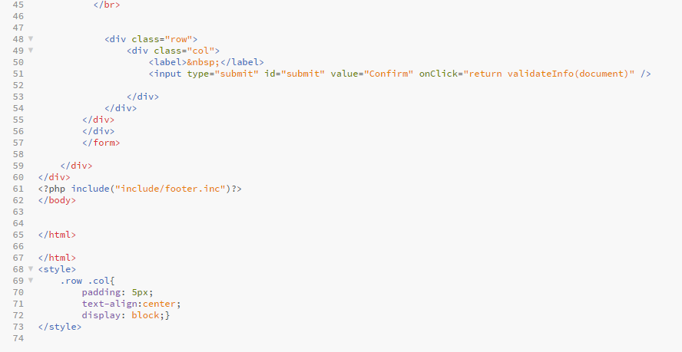

Contactus

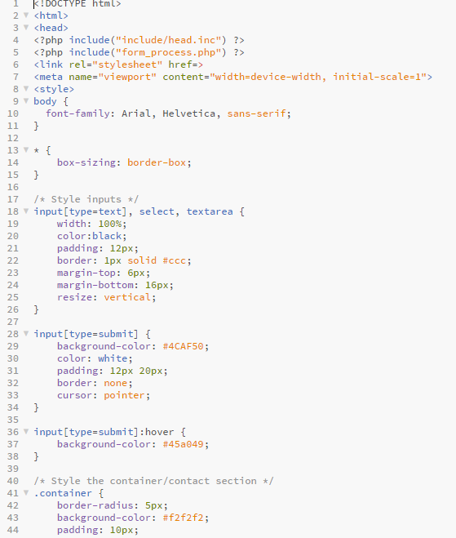

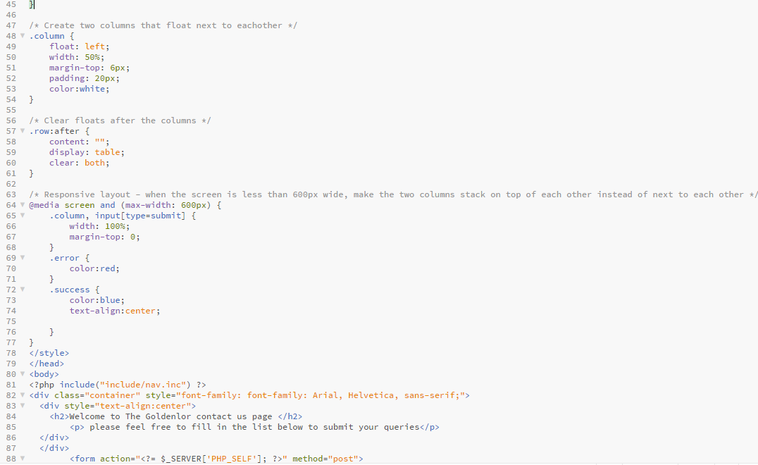

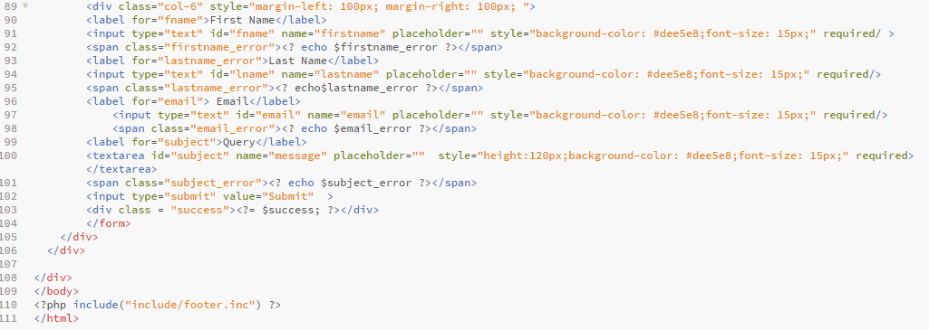

Form_process

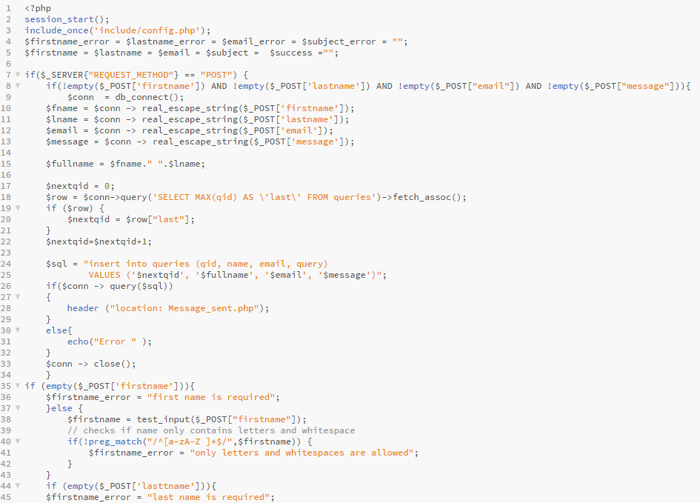

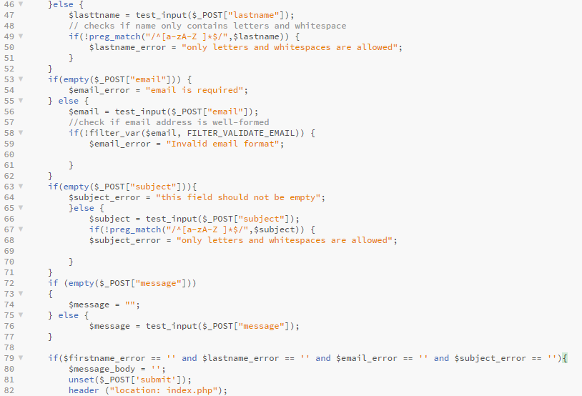

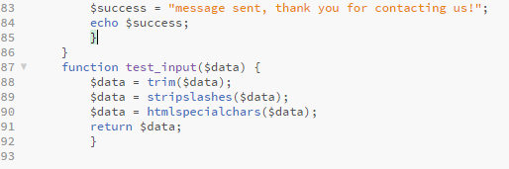

ICTproj

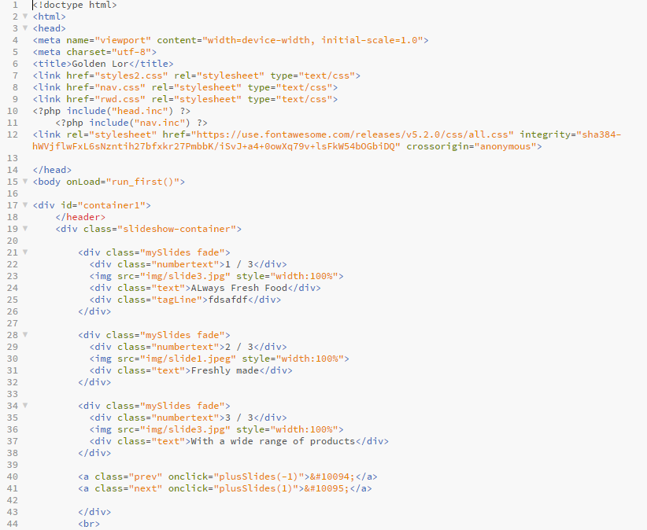

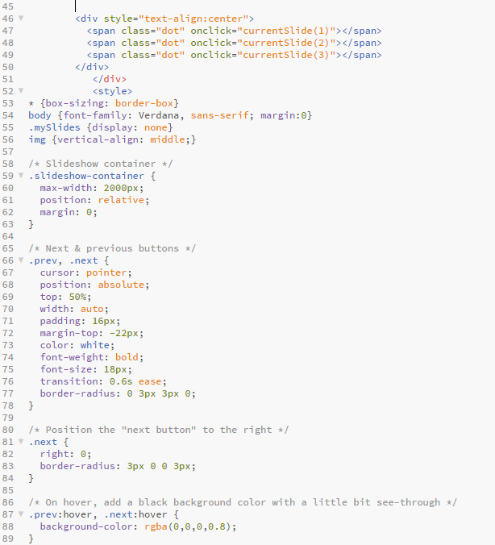

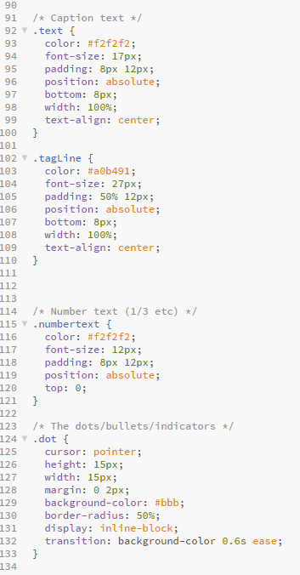

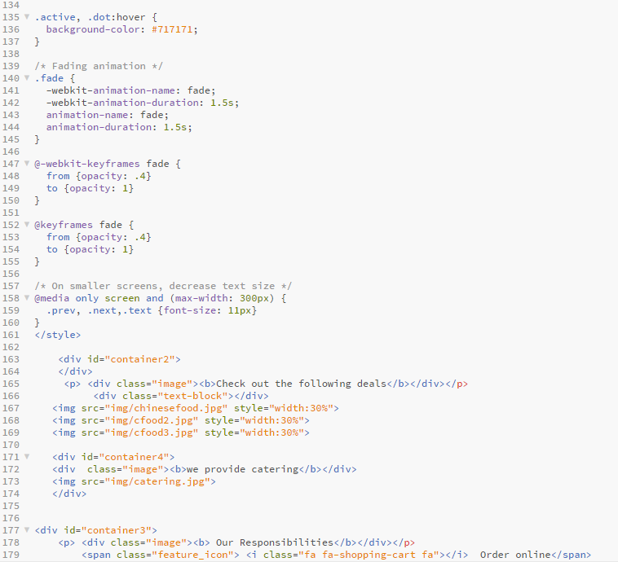

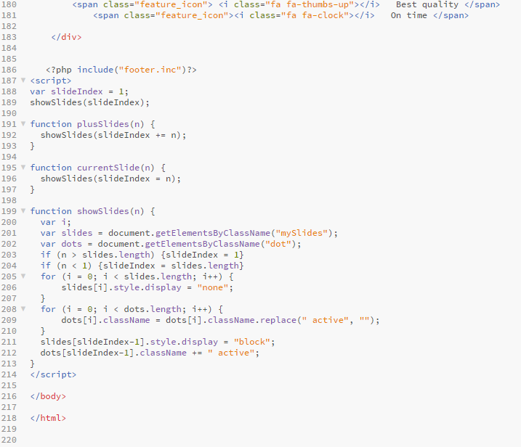

Index

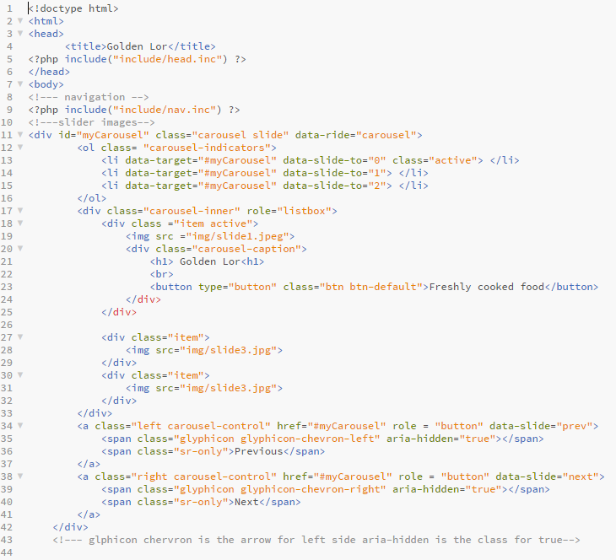

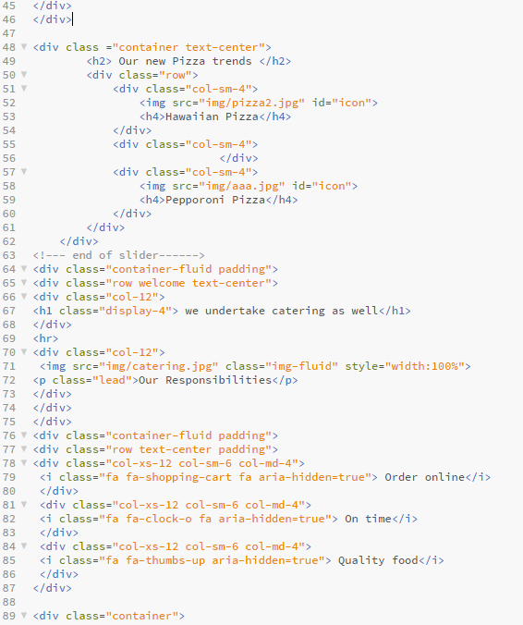

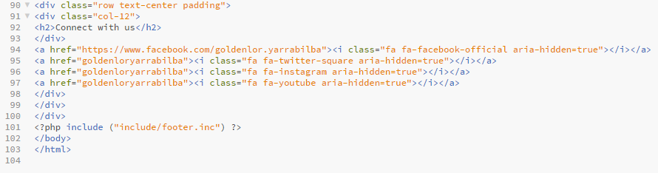

Menu

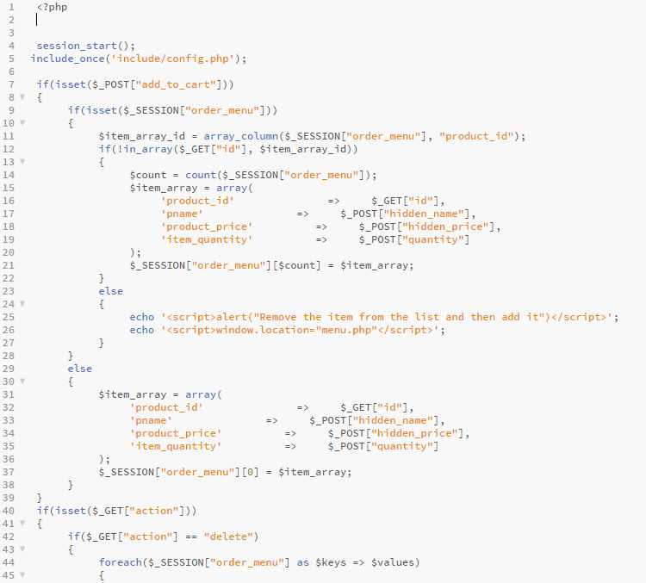

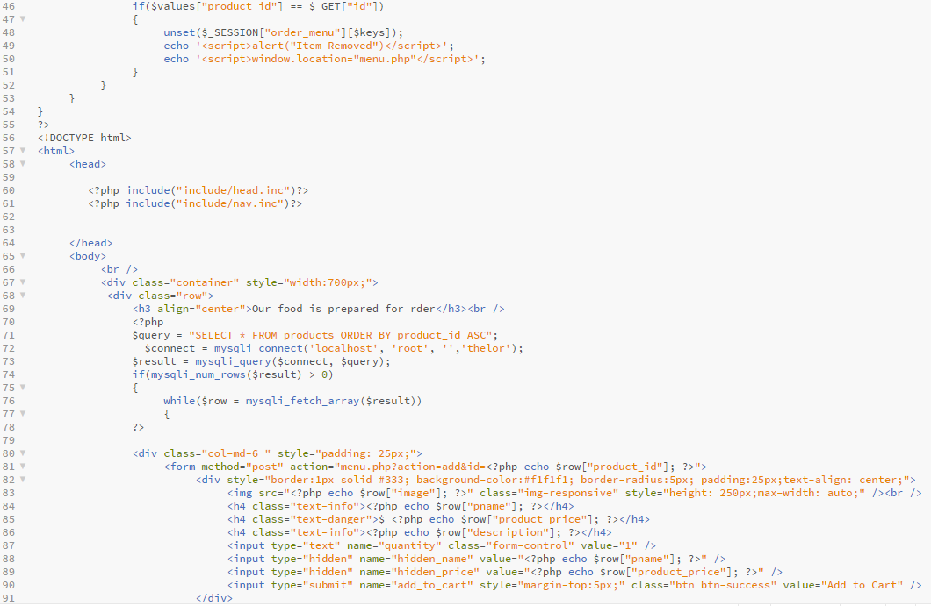

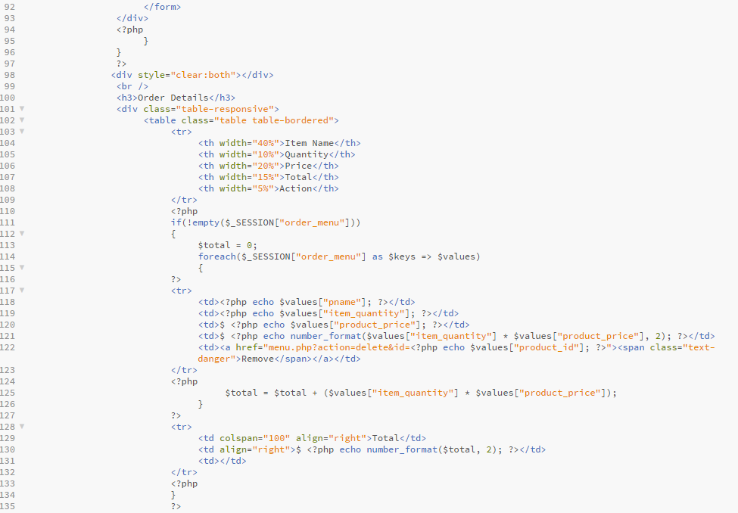

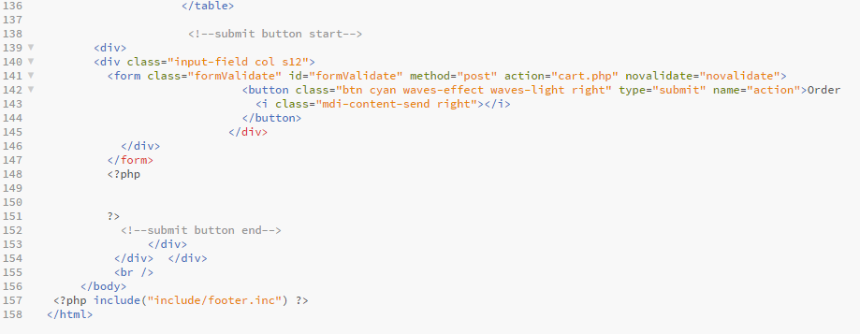

Message_sent

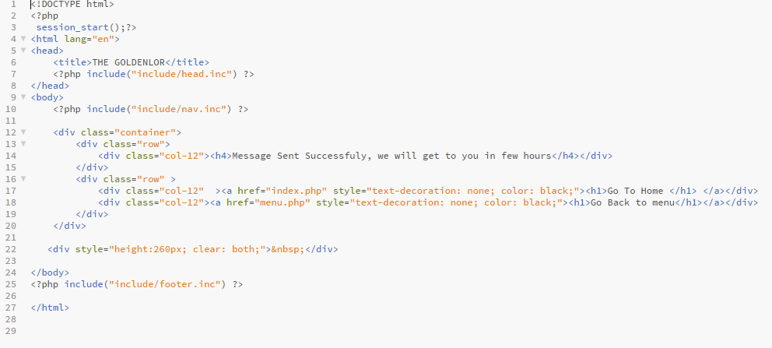

Mystyles

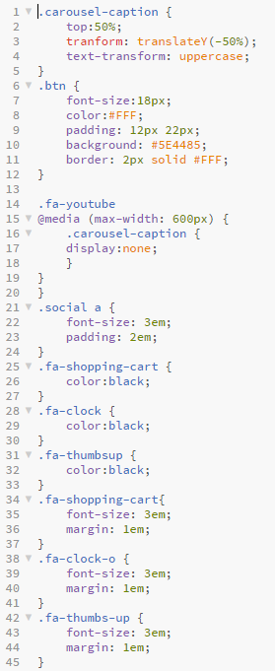

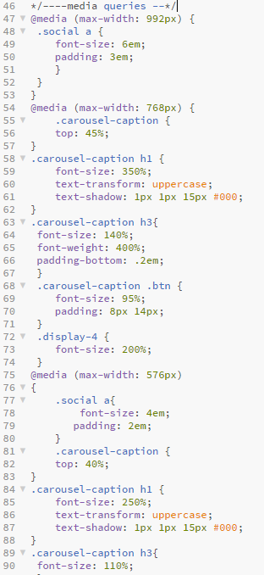

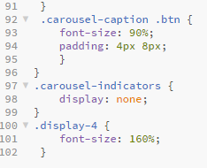

Nav

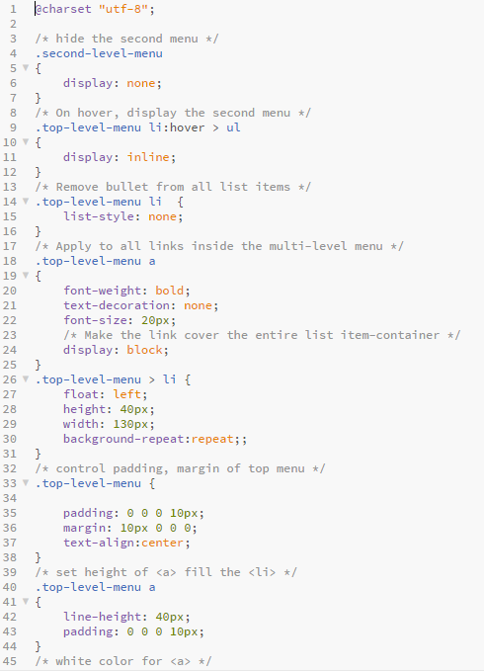

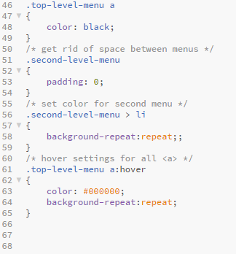

Navigation

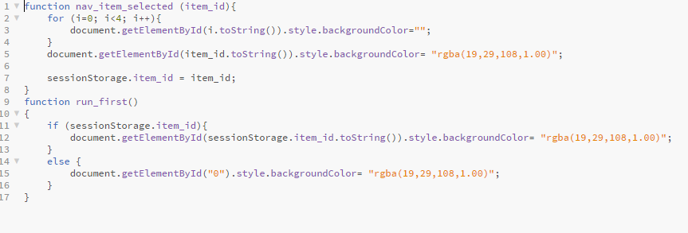

Order_item

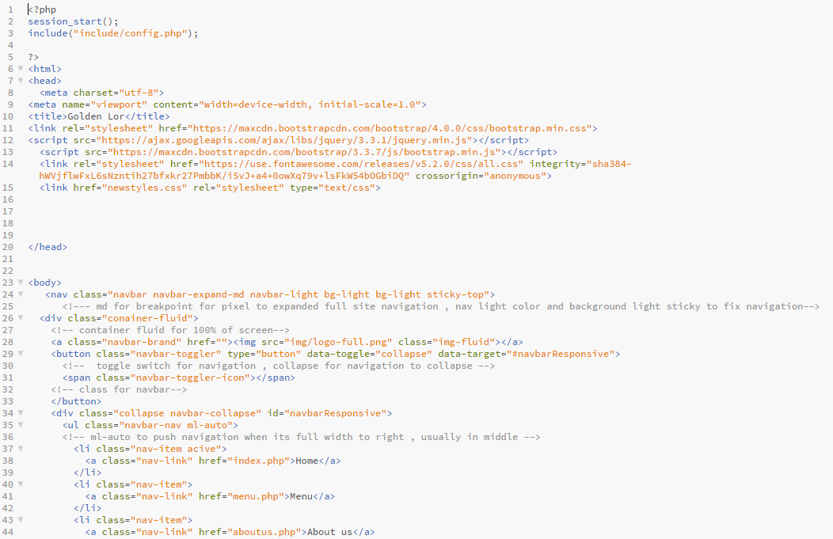

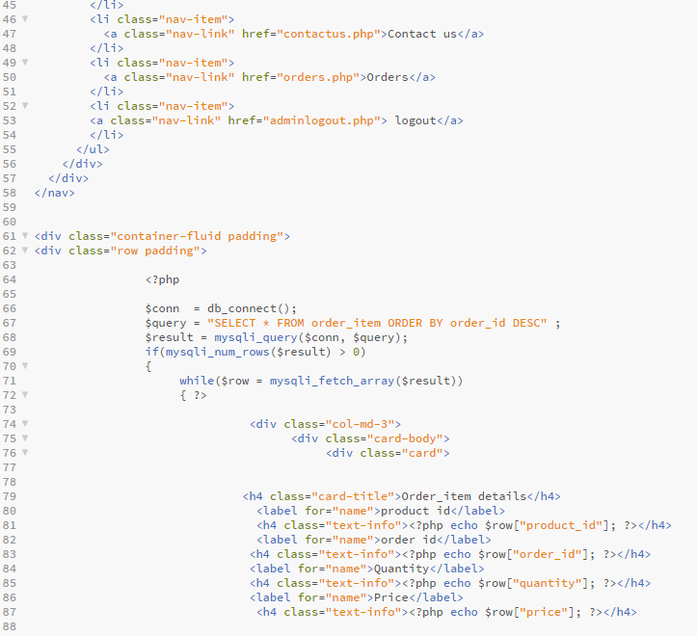

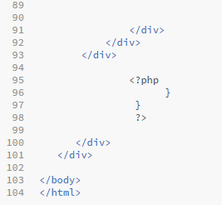

Orderprocess

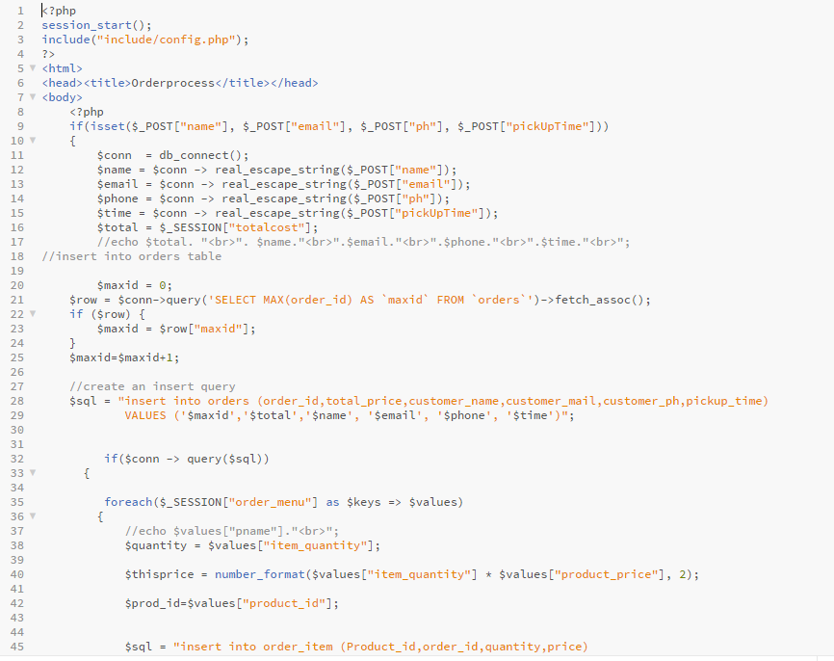

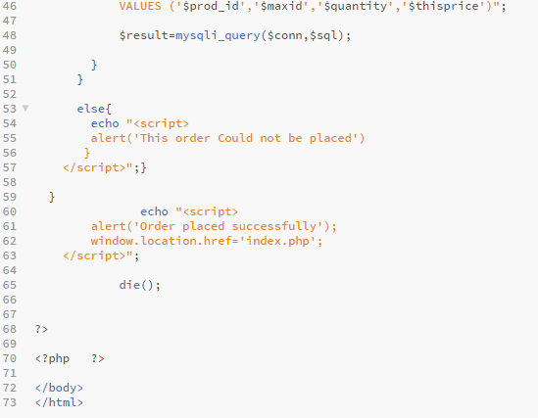

Orders

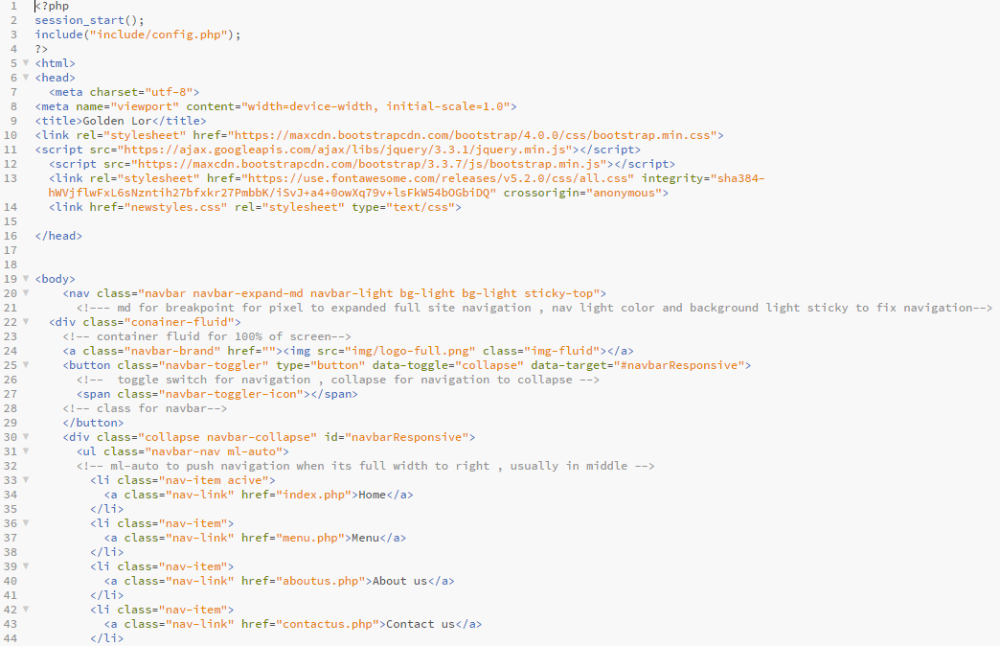

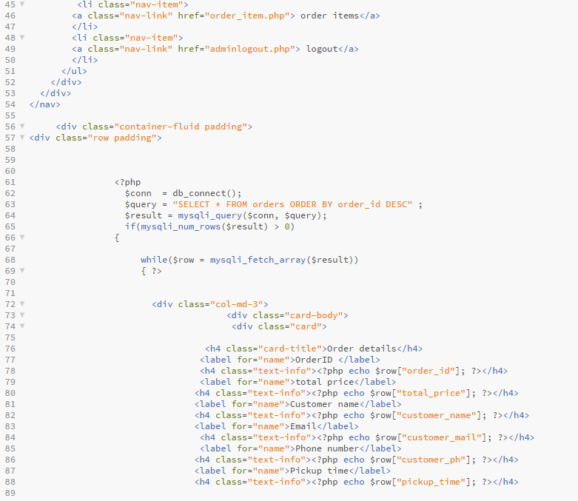

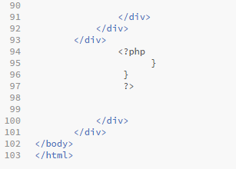

Pickup

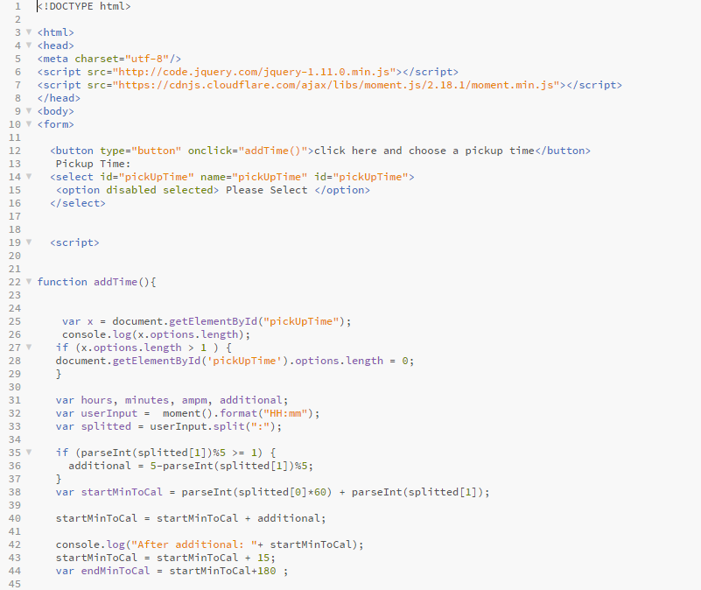

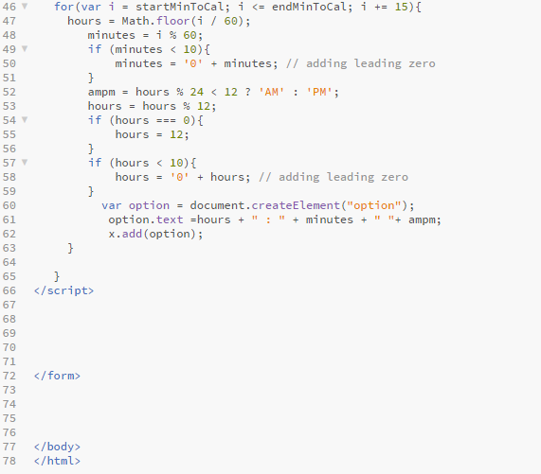

Thelor

